

Enter Qualifying Round – Chosen team will enter the algorithm process that will deem where they should be placed.

Champions League Spot in League – Check done to see if the selected team has finished in a champions league spot in their respective league. If not in the right spot they are ineligible.

Group Stage(Country Rank) – The program will check the country ranking for the teams country. If the country is ranked 1-13 they will Enter the Group Stage Pot. Otherwise they enter the qualifying route.

Champions Route – If the team has won their league they will enter the Champions Route. If they are not champions but are eligible for the Champions League they will enter the Non-Champions Route.

3rd Round(Country Rank) – The Country Rank for the team will determine if they enter the 3rd or 4th qualifying round.

Seeded(3rd round) – The current team ranking of the selected team will determine whether they are seeded or not. This is finalised by taking all teams in the pot for the 3rd round and arranging them by rank. Of the 10 teams in the pot the top 5 ranked are seeded, the bottom them are unseeded.

Seeded(4th round) – The current team ranking of the selected team will determine whether they are seeded or not. This is finalised by taking all teams in the pot for the 4th round and arranging them by rank. Of the 10 teams in the pot the top 5 ranked are seeded, the bottom them are unseeded.

1st Round(Country Rank) - The Country Rank for the team will determine if they enter the 1st round. Otherwise they will either enter the 2nd or 3rd round.

Seeded(1st Round) - The current team ranking of the selected team will determine whether they are seeded or not. This is finalised by taking all teams in the pot for the 1st round and arranging them by rank. Of the 8 teams in the pot the top 4 ranked are seeded, the remaining 4 are unseeded.

2nd Round(Country Rank) - The Country Rank for the team will determine if they enter the 2nd round. Otherwise they will either enter the 3rd round.

Seeded(2nd Round) - The current team ranking of the selected team will determine whether they are seeded or not. This is finalised by taking all teams in the pot for the 2nd round and arranging them by rank. Of the 34 teams in the pot the top 17 ranked are seeded, the remaining 17 are unseeded.

Seeded (3rd Round) - The current team ranking of the selected team will determine whether they are seeded or not. This is finalised by taking all teams in the pot for the 3rd round and arranging them by rank. Of the 20 teams in the pot the top 10 ranked are seeded, the remaining 10 are unseeded.

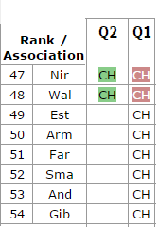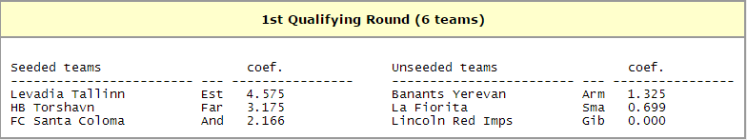

Note: Due to Special circumstances 2 teams from round 1 were promoted to round 2. Therefore the seeding was calculated for 6 teams rather than 8. (Benfica Winning the Europa League)

Example: Levadia Tallinn

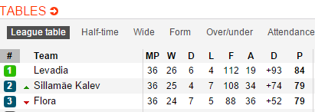

Levadia have won their League therefore will enter the Champions Route



Levadia’s Country Estonia are currently ranked 49th in Europe therefore the team who wins their league enters the first round.



Levadia are to be seeded in round one. This is because of the 6 teams in the round Levadia are ranking in the top 3.